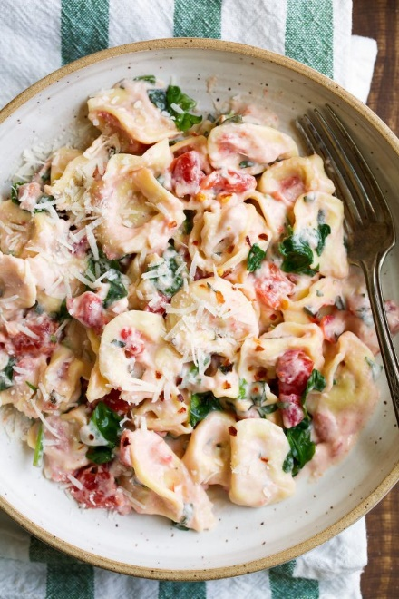
Spinach Tomato Pasta
Prep time 10 min Cook time 15 min
6 Servings
Ingredients
1 lb rotini pasta
3 tbsp butter
2 cloves garlic, minced
3 tbsp flour
1 tsp onion powder
1¼ cups milk
½ cup heavy cream
(2) 14.5 oz cans petite diced tomatoes, undrained
1½ cups chopped fresh spinach
3 tbsp chopped fresh basil
½ tsp oregano
Salt and freshly ground black pepper
½ cup finely shredded parmesan cheese
Red pepper flakes, for serving
Directions
- Cook pasta according to package directions.
- Meanwhile, in a large skillet, melt butter over medium heat. Add garlic, flour and onion powder. Cook 1 minute stirring constantly.
- Slowly pour in milk and cream and whisk until smooth.
- Cook, stirring constantly, until mixture begins to barely simmer and thicken. Then add tomatoes, spinach, basil, oregano and parmesan. Season with salt and pepper to taste.
- Reduce heat slightly and cook several minutes longer until sauce has thickened and cheese has melted. Remove from heat.
- Toss pasta into sauce mixture. Thin sauce with a little pasta water or milk as needed.
- Serve warm sprinkled with additional parmesan cheese and optional red pepper flakes.
Notes
Add chicken to sauce and serve over pasta
Serve sauce over tortellini instead of pasta

